- February 2024 “A lovng heart is the beginning of all knowledge”Thomas Carlyle

SUNDAY | MONDAY | TUESDAY | WEDNESDAY | THURSDAY | FRIDAY | SATURDAY
 |  |  | 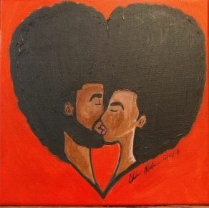 | 1  Yoga @ Bodhi yoga  6pm | 2  Plymouth Ice  Festival 6pm  -Ice sculptures, live music, hot chocolate | 3  Royal Oak  Winter blast 12-3pm  Happy Birthday  Wendell!
4  Bee’s Knees  2pm | 5  Bowling League 6:30pm | 6  Taco Tuesday @ Grand Tavern 4pm  Happy Birthday David! | 7  Black History Party @OLH 3  4:30pm | 8  BIA Support Group @ Botsford 7:00pm | 9  Fish Fry in Redford  5:30pm | 10  Winter Love Fest  @ Palmer Park 2-5pm  -Musicians, African Dancing, vendors and Hot Choclate in Log Cabin in Palmer Park
11  Watch Super Bowl 6pm @ OLH 3  -Appetizers only, please eat dinner prior to the game!  Happy Birthday  Bobby and Jose!!!!! | 12  Bowling League 6:30pm | 13  Fat Tuesday Party @ OLH 3 - 4:30pm | 14  Valentine’s Day  Party @ 4:30pm | 15  Yoga @ Bodhi yoga  6pm | 16  ‘Lend Me a Tenor’  @ Farmington Player’s Barn  8:00pm | 17  Joe Turner’s Come & Gone @ Detroit  RepertoryTheatre  2:45pm
18  Go Comedy!  Improv theatre in Ferndale 7-9pm | 19  Bowling League 6:30pm | 20  Taco Tuesday @ Grand Tavern 4pm | 21  Bowling League 6:30pm | 22  Yoga @ Bodhi yoga  6pm | 23  Movie’s 6pm | 24  Monster Jam @ Ford Field 4pm  Happy Birthday  Richard!
25  Mall Walk 2pm | 26  Bowling League 6:30pm | 27  Library 5pm | 28  “Anything Goes”  Dinner @ OLH 3  4:30pm | 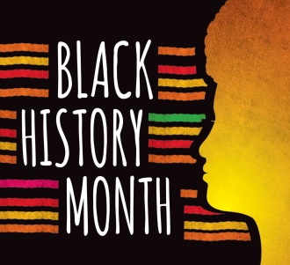 | 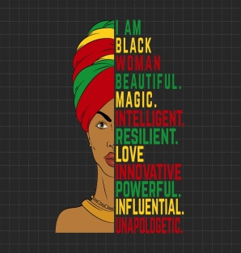 | 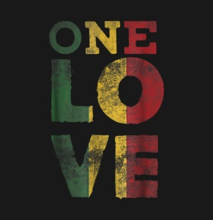
Any questions regarding activities call Kelly @ 248-234-0718

