SUNDAY | MONDAY | TUESDAY | WEDNESDAY | THURSDAY | FRIDAY | SATURDAY
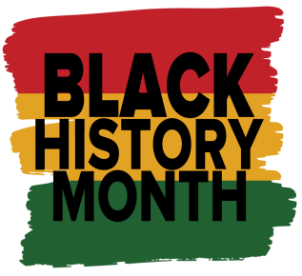 |  |  | 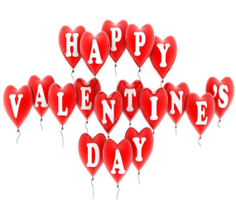 | 1  USA Hockey Game in Plymouth  7:00pm | 2  Plymouth Ice Festival  6:00-8:00p  *Ice sculptures, music, vendors, food* | 3  Royal Oak Winter Blast 12:00-3:00pm  *Ice sculptures, music, food trucks*  Happy Birthday Wendell!
4  Bees Knees Pottery  1:00-3:00pm  Happy Birthday David! | 5  Bowling @ Perfect Game 6:00-8:00pm  Bowling League 6:30pm | 6  Motor City Cruise Basketball Game (NBA G-League)  7:00pm | 7  “Anything Goes” Dinner @ OLH3  4:30-6:30pm | 8  Out to Eat  4:30-6:30pm  *Clients pay for their own meal* | 9  Sterling Heights Dance  6:00-9:00pm | 10  Dueling Piano Bar & Dinner in Royal Oak  6:45-9:00pm  *Clients pay for their own meal*
11  Super Bowl Party @ OLH3  6:00-10:00pm  Happy Birthday Jose & Bobby! | 12  Bowling @ Perfect Game 6:00-8:00pm  Bowling League 6:30pm | 13  Fat Tuesday/Mardi Gras Party @ OLH3 4:30-6:30pm | 14  Valentine’s Day Party @ OLH3  4:30-6:30pm | 15  Bingo on Zoom  6:00pm | 16  Fish Fry Dinner in Redford  5:30-7:30pm | 17  Detroit Roller Derby @ Masonic Temple  5:00pm
18  Go Comedy! Improv in Ferndale  7:00pm | 19  Bowling @ Perfect Game 6:00-8:00pm  Bowling League 6:30pm | 20  Mall Walk  6:00-7:30pm  *Times can vary* | 21  “Anything Goes” Dinner @ OLH3  4:30-6:30pm | 22  Trivia Night on Zoom  6:00pm | 23  Lend Me a Tenor Play @ Farmington Players Barn  8:00pm  *Comedy* | 24  Monster Jam @ Ford Field  5:00pm  Happy Birthday Richard M!
25  Valentine’s (Romantic Comedies) Movie Marathon & Pizza Party @ OLH2  4:30-8:30pm | 26  Bowling @ Perfect Game 6:00-8:00pm  Bowling League 6:30pm | 27  Bingo & Snacks @ OLH2  5:30-7:30pm | 28  “Anything Goes” Dinner @ OLH3  4:30-6:30pm | 29  Movie Theater  Time TBD

