SUNDAY | MONDAY | TUESDAY | WEDNESDAY | THURSDAY | FRIDAY | SATURDAY
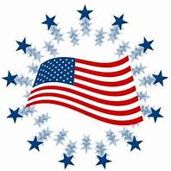 | 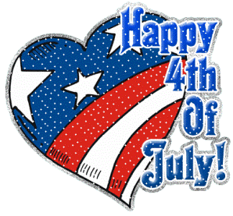 |  | 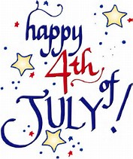 |  |  | 1  Royal Oak Taco Fest  12:30-3:30pm  *Food, Music, Wrestling Match*
2  Kensington Park Fireworks  9:30pm | 3  Bowling @ Perfect Game  6:00-8:00pm | 4  4th of July Party @ OLH3  12:00-2:30pm | 5  “Anything Goes” Dinner @ OLH3  4:30-6:30pm  Happy Birthday Carolyn! | 6  Bingo on Zoom  6:00pm | 7  Jimmy Johns Baseball Game & Fireworks  7:00pm  Happy Birthday Fred! | 8  Dinner & Merge (Variety, Pop Music) @ Partridge Creek Mall 5:00-8:00pm  *Clients pay for own meal*
9  Tiger’s Game  1:40pm | 10  Bowling @ Perfect Game  6:00-8:00pm | 11  Detroit Retro Society Band @ Novi Fountain Walk  6:00-8:00pm | 12  “Anything Goes” Dinner @ OLH3  4:30-6:30pm  Hip-Prov @ Ant Hall  8:00pm | 13  Lazo & Exodus (Reggae Music) @ Dodge Park  7:00pm  *Music, food trucks, farmers market* | 14  Soul Express (Funky Motown Soul) @ Riley Park  7:00pm | 15  African World Festival in Detroit  12:00-3:00pm
16  Activity Day with Danielle @ OLH3  1:00-3:00pm | 17  Bowling @ Perfect Game  6:00-8:00pm | 18  Eat It Up Trio Band @ Novi Fountain Walk  6:00-8:00pm | 19  “Anything Goes” Dinner @ OLH3  4:30-6:30pm | 20  Trivia Night on Zoom  6:00pm | 21  Outdoor Movie-The Woman King @ New Center Park in Detroit  8:00-11:00pm | 22  Movie Theater  Time TBD
23  Out to Eat 4:30-6:30p  *Clients pay for their own meal*  30  Walk @ Park & DQ  1:00-2:30pm | 24  Bowling @ Perfect Game 6:00-8:00pm  31 Happy Birthday Linda!  Bowling @ Perfect Game 6:00-8:00pm | 25  Bingo & Snacks @ OLH2  6:00-8:00pm | 26  “Anything Goes” Dinner @ OLH3  4:30-6:30pm | 27  Yoga on the Riverfront  6:00pm | 28  Rockin On The River  Queen Nation (Queen Covers) & Black River (Classic Rock 70-90’s)  in Detroit  6:00-11:00pm | 29  Sterlingfest @ Dodge Park  12:30-3:00pm

